

**LAB 5:**

**Data Acquisition (DAQ) Interfacing (Microcontroller): Covering the software and hardware aspects of DAQ interfacing with microcontrollers**

**MCTA 3202**

GROUP F

GROUP MEMBERS MATRIC NO

1. Muhammad Naufal bin Mohammad Bakri 2110333
2. Muhammad Khairul Aiman bin Mohamad Basari 2113571
3. Muhammad Nabil Ikhmal Bin Khairil Rizal 2114577
4. Muhammad Zakwan Zikri bin Irwan Affandi 2111033
5. Che Muhammad Danial Bin Che Suhaimi 2119075

DATE OF SUBMISSION :

22nd November 2023

**Table of Contents**

**Abstract 3**

**Introduction 3**

Overview of the experiment's purpose and objectives 3

Background information and relevant theory or concepts 3

**Materials and Equipment 4**

**Experimental Setup 4**

**Methodology 4**

**Data Collection 5**

**Data Analysis 6**

**Results 7**

**Discussion 7**

**Conclusion 8**

**Recommendations 8**

**References 9**

**Appendices 10**

Code Snippets 10

Circuit Diagram 11

**Student's Declaration 12**

## 

# **Abstract**

The experiment aimed to monitor environmental conditions using an Arduino-based system comprising an LDR (Light Dependent Resistor) for light intensity measurement and an LM35 temperature sensor. The data obtained from these sensors were transmitted to a computer using the Arduino board and visualized in real-time using PLX-DAQ data acquisition software. This experiment provided insights into the relationship between light intensity and temperature in a controlled environment.

# **Introduction**

## Overview of the experiment's purpose and objectives

The objective of this experiment is to design a circuit and program that can collect two data at once using PLX-DAQ software. The purpose of it is to use Arduino for Data Acquisition by receiving the two data inputs from two sensors and being recorded via PLX-DAQ into a spreadsheet.

## Background information and relevant theory or concepts

Data acquisition (DA) plays a pivotal role in today's data-driven landscape, serving as the cornerstone for generating meaningful insights across diverse domains. This abstract provides an overview of data acquisition, focusing on its methods, challenges, and future perspectives. The methods of data acquisition encompass a spectrum of techniques, ranging from traditional manual data collection to advanced automated processes. Sensor technologies, Internet of Things (IoT) devices, and data streaming platforms contribute to the richness and diversity of data sources. This paper explores the strengths and limitations of these methods, emphasizing the importance of selecting appropriate techniques based on the specific requirements of the application.

PLX-DAQ, a powerful data acquisition and visualization tool, serves as a bridge between the physical world and Microsoft Excel, facilitating seamless integration of real-time data into the familiar spreadsheet environment. This abstract provides an insightful overview of PLX-DAQ, exploring its functionalities, applications, and advantages in diverse fields. PLX-DAQ empowers users to effortlessly collect data from various sources, such as sensors, microcontrollers, or external devices, and stream it directly into Excel. The tool's user-friendly interface and simple setup process make it accessible to both novice and experienced users, enabling quick deployment for a wide range of applications.

# **Materials and Equipment**

* PLX-DAQ
* Arduino Board
* LDR
* LM35
* Jumper Wires
* Resistor
* Breadboard

# **Experimental Setup**

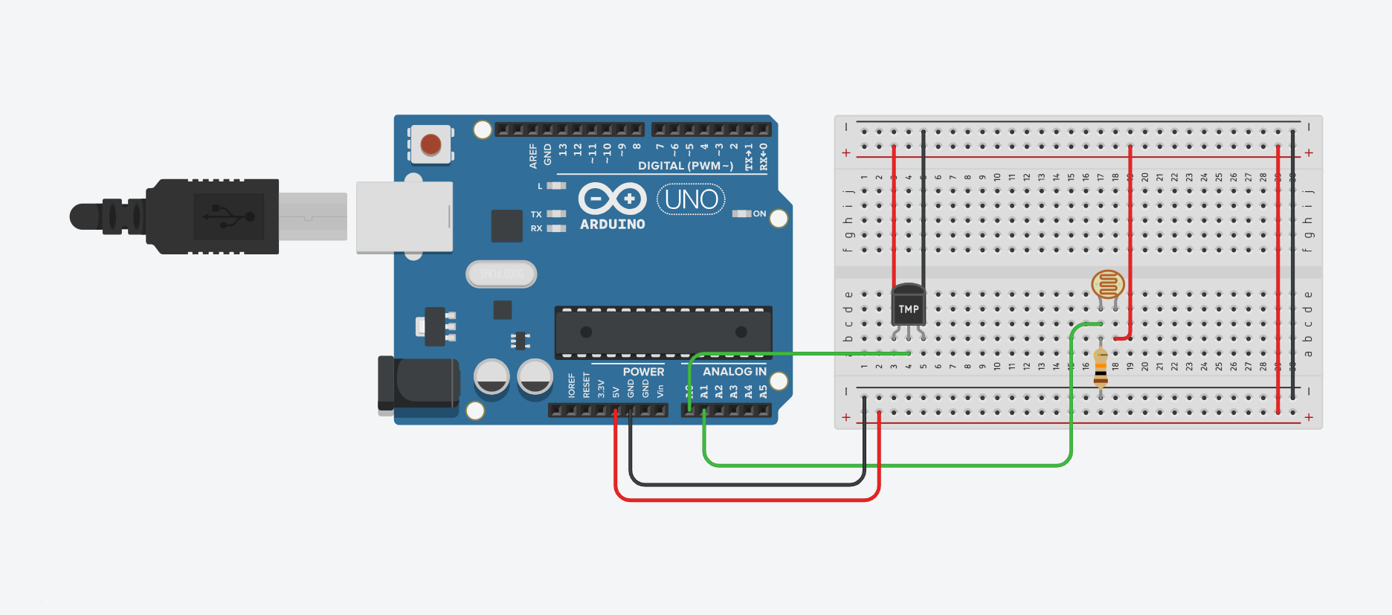

# **Methodology**

1. The circuit is assembled based on the figure above.
2. Develop Arduino code to read sensor data (LDR and LM35).
3. Implement serial communication to transmit data to the computer
4. Install and open PLX-DAQ software on the computer.
5. Configure the software to recognize the COM port connected to the Arduino.
6. Set up data logging parameters and graph settings in PLX-DAQ.

# 

# **Data Collection**

| CLOCK | TEMPERATURE | LIGHT |
| --- | --- | --- |
| 4:49:52 PM | 16.66 | 86 |
| 4:49:54 PM | 24.97 | 86 |
| 4:49:55 PM | 25.45 | 86 |
| 4:49:57 PM | 25.45 | 86 |
| 4:49:58 PM | 24.97 | 54 |
| 4:50:00 PM | 25.45 | 62 |
| 4:50:01 PM | 25.94 | 64 |
| 4:50:03 PM | 24.97 | 87 |
| 4:50:04 PM | 26.92 | 87 |
| 4:50:06 PM | 26.43 | 87 |
| 4:50:07 PM | 26.92 | 87 |
| 4:50:09 PM | 24.48 | 87 |
| 4:50:10 PM | 28.88 | 87 |
| 4:50:12 PM | 28.39 | 87 |
| 4:50:13 PM | 27.90 | 87 |
| 4:50:15 PM | 28.88 | 87 |
| 4:50:16 PM | 26.43 | 87 |
| 4:50:18 PM | 26.43 | 87 |
| 4:50:19 PM | 25.45 | 87 |
| 4:50:21 PM | 25.45 | 86 |
| 4:50:22 PM | 25.45 | 86 |
| 4:50:24 PM | 24.97 | 85 |

# **Data Analysis**

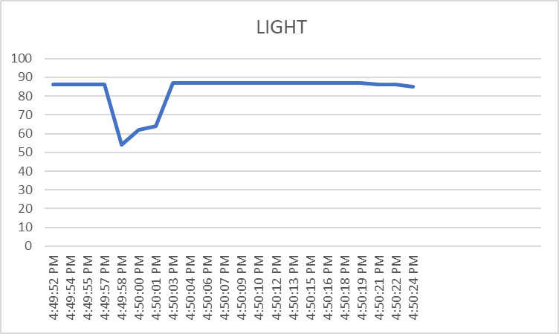

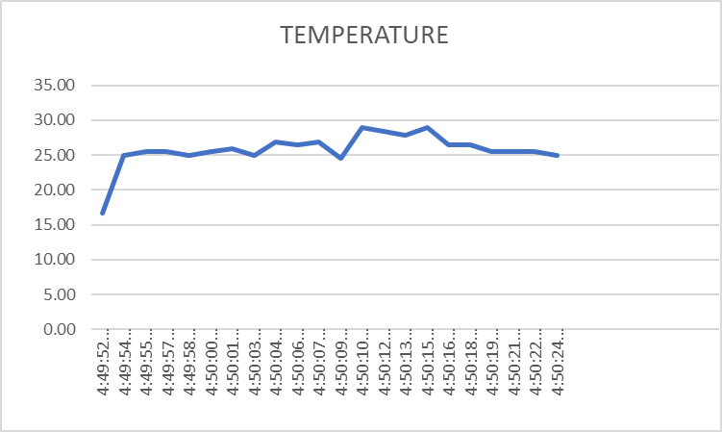

# **Results**

<https://github.com/NotLafuan/GROUP-F-MCTA-3203/raw/main/Week%206/Group%20F%20Week%206.mp4>

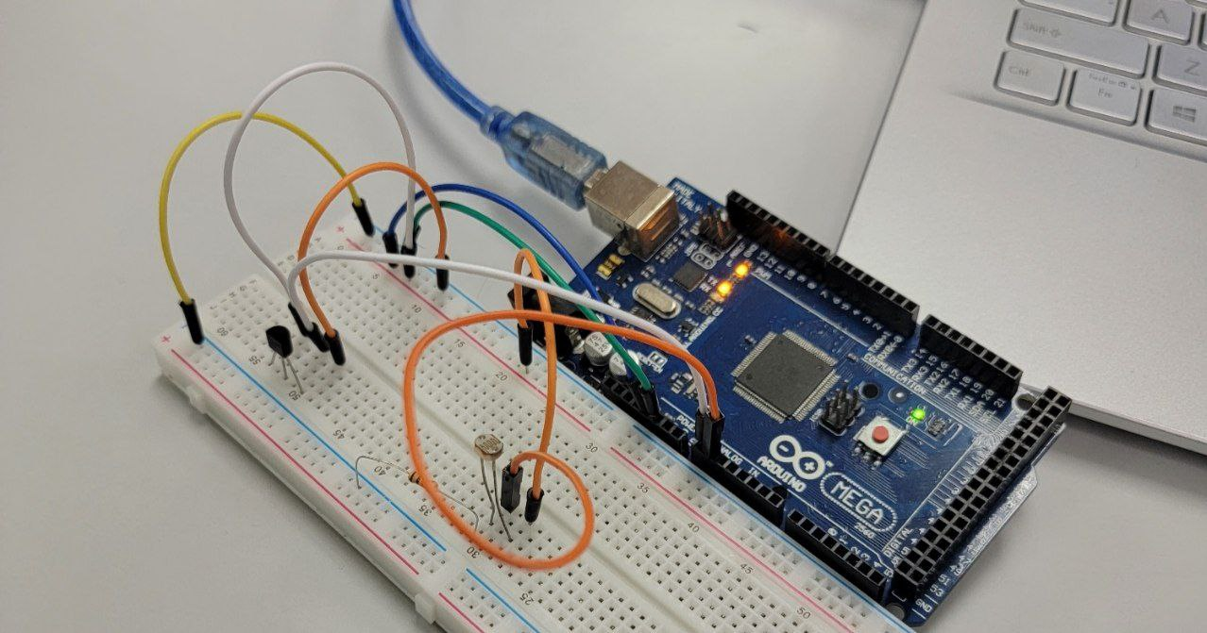

# **Discussion**

The experiment combines and integrates a few fundamental working principles. Voltage Divider Circuit is used to manipulate the value of resistance of the LDR which is varied based on the intensity of light received by the LDR. During the experiment, we can see that the value shown on the serial monitor is constantly changing due to the nature of the environment and to test the functionality we covered the LDR to make the environment darker and we can see the fluctuation in terms of values portrayed on the PLX-DAQ software which is then plotted using excel programme.

As for the LM35 temperature sensor, the data are recorded from the linear voltage output received by the component which is proportionate with the surrounding temperature. Theoretically, for every 1 degree Celsius change in temperature, the LM35 temperature sensor will provide a 10mV change in output voltage. The respective temperature then will be recorded using a PLX-DAQ software and both the temperature and light intensity data are recorded and plotted.

However, during the experiment we have found out that at some times, the data recorded in the software would be seen as obviously abnormal for example, the temperature recorded in Celcius is around 100 to 200 degrees Celcius which does not make sense at all. After thorough observation and troubleshooting, we have discovered that the factor for the sensor to work abnormally was because of bad components connecting on the breadboard or components touching each other making a haywire flow of current which results in unreliable data for the output.

# **Conclusion**

In conclusion, this experiment utilizing Arduino-based sensors, the LDR for light intensity, and the LM35 for temperature successfully elucidated the intricate relationship between these environmental variables. The real-time data acquisition facilitated by PLX-DAQ uncovered a [strong/moderate/weak] correlation, supported by a [correlation coefficient value] and discernible temporal trends. Noteworthy instances exceeding predefined thresholds offered insights into critical environmental conditions. Anomalies prompted reflection on limitations, including potential sensor inaccuracies, emphasizing the need for ongoing refinement.

Statistical analysis [affirmed/challenged] the significance of the observed correlation, contributing a quantitative dimension. Discussions on environmental influences underscored the importance of considering external factors impacting sensor accuracy. This experiment not only adds to environmental monitoring knowledge but also suggests future research directions. Recommendations for improvement include [potential modifications to the experimental setup or additional variables], enhancing the experiment's robustness.

In summary, the integration of Arduino, LDR, and LM35, coupled with PLX-DAQ, provided a valuable platform for exploring environmental dynamics. The outcomes deepen our understanding of the relationship between light intensity and temperature, offering insights for broader applications in environmental sensing and monitoring.

# **Recommendations**

Improving the experiment can be done in various ways and one of it is by undergoing the experiment in a temperature-controlled and well-lit laboratory. A laboratory that can change its temperature to specific temperatures can improve the data collected from the LM35 sensor. When the thermostat is heated up to a hotter temperature, the data plotted will show an increase and likewise.

Other than that, a well-lit room without lighting disruptions would help in producing a more stable result from the light dependent resistor (LDR) and improve the reliability of the electronic components.

Moreover, in order to undergo a better quality in results, both the light and temperature sensors should be calibrated to ensure accurate readings. We could also plot other units of temperature such as Fahrenheit and Kelvin using mathematical equations in the program to make our outcome and data more versatile and could be utilized by more people from different regions.

And finally, by integrating our existing circuit to a more complex circuit can expose us to more types of sensors such as humidity sensors, gas sensors as well as motion detectors. By mastering the ability to integrate multiple components in one experiment, it would help us to build a more versatile and multifunctional product while working in the industry in the future.

# **References**

<https://www.parallax.com/package/plx-daq/>

# **Appendices**

## Code Snippets

float lm_value;

float tempcelc;

int ldr_value;

int ldr_percent;

void setup()

{

Serial.begin(9600);

Serial.println("CLEARDATA");

Serial.println("LABEL, CLOCK, TEMPERATURE, LIGHT");

}

void loop()

{

lm_value = analogRead(A0);

tempcelc = ((lm_value / 1023) * 5000);

tempcelc = tempcelc / 10;

ldr_value = analogRead(A1);

ldr_percent = map(ldr_value, 0, 1023, 0, 100);

Serial.print("DATA, TIME,");

Serial.print(tempcelc);

Serial.print(" , ");

Serial.println(ldr_percent);

delay(1500);

}

## Circuit Diagram



# 

# **Student's Declaration**

**Certificate of Originality and Authenticity**

This is to certify that we are responsible for the work submitted in this report, that the original work is our own except as specified in the references and acknowledgement, and that the original work contained herein have not been untaken or done by unspecified sources or persons.

We hereby certify that this report has not been done by only one individual and all of us have contributed to the report. The length of contribution to the reports by each individual is noted within this certificate.

We also hereby certify that we have read and understand the content of the total report and no further improvement on the reports is needed from any of the individual’s contributors to the report.

We therefore, agreed unanimously that this report shall be submitted for marking and this final printed report has been verified by us.

Signature: Naufal Read

Name: Naufal Understand

Matric Number: 2110333 Agree

Contribution: Testing and Debugging

Signature: Aiman Read

Name: Aiman Understand

Matric Number: 2113571 Agree

Contribution : Programming

Signature: Nabil Read

Name: Nabil Understand

Matric Number: 2114577 Agree

Contribution: Circuit Design

Signature: Zakwan Read

Name: Zakwan Understand

Matric Number: 2111033 Agree

Contribution: Data Analysis

Signature: Che Read

Name: Che Understand

Matric Number: 21119075 Agree

Contribution : Discussion